PLACE OF MEETING OF PROFESSIONALS OF TRANSPORT INDUSTRY
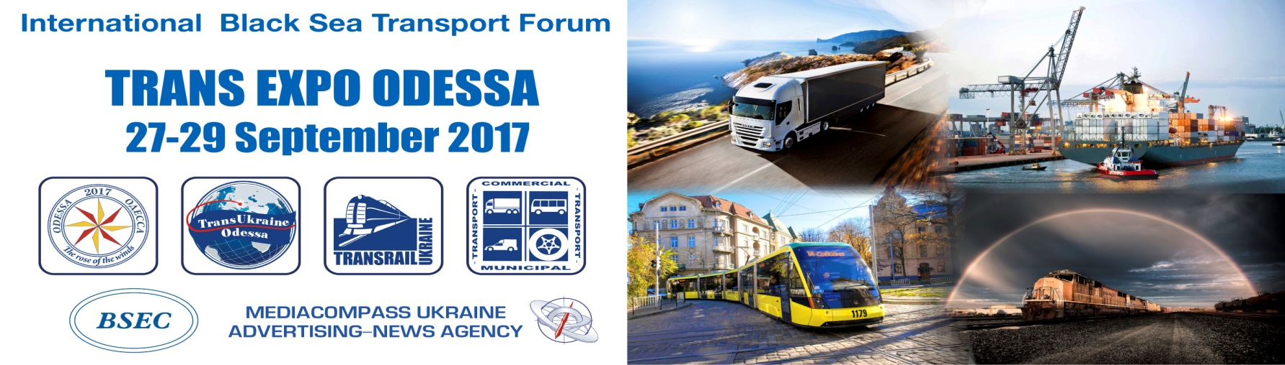
The annual significant event in the transport industry of Ukraine - TRANS EXPO ODESSA 2017 (International Black Sea Transport Forum 2017) which finished its work on September 29th in Odessa. The event showed interest of transport community to Ukraine as a transit hub.
Within 3 days the Forum became a platform for exchange of experience and discussion of topical issues, a meeting place for business partners.
TRANS EXPO ODESSA united the 20th international exhibition on transport and logistics “TransUkraine 2017”, the 14th international exhibition on shipping, shipbuilding, ports development “Odessa 2017”, the international specialized exhibition “TransRail Ukraine 2017”, The 20th international conference "Transport system of Ukraine in the system of transcontinental transport routes".
Coordinators of exhibitions and conference are the Ministry of infrastructure of Ukraine and the Black and Azov Sea Ports Association (BASPA).
The events are also supported by Ministry of foreign affairs of Ukraine, Ministry of economic development and trafe of Ukraine, Odessa regional administration, Odessa city council, Black Sea International Shipowners Association (BINSA), Black Sea Region Association of Shipbuilders and Shiprepairers (BRASS), Danube Commission, Intergovernmental Commission TRACECA, Association of Ukrainian ports “UKRPORT”, Container Lines Association of Ukraine, European Business Association, Association of Ukrainian Shipbuilders «Ukrsudprom», Association “Ukrainian logistics Alliance”, Federation of Employers in Transport of Ukraine, European Association of transport workers of Ukraine, Association of International Forwarders of Ukraine, Association of International Road Carriers of Ukraine.
General sponsor of the Forum was the Turkish company TURMAR MARINE, which represents 11 shipyards of Europe and Asia, as well as 16 shipyards in the Far East.
On their stand representatives of the Ministry of Infrastructure of Ukraine held regular business meetings and negotiations with representatives of foreign and domestic companies interested in cooperation with governmental and state structures in the field of transport. Railway industry of Ukraine was represented by PJSC "Ukrzaliznytsya" and JSC "Plaske".
Turkish shipbuilding industry was represented by the Turkish Association of Shipbuilders GISBIR, which held a number of successful B2B meetings and negotiations, as well as the shipyard TERSAN SHIPYARD, whose stand attracted the attention of visitors to the Forum. BULUTLU MARINE provided consulting services for ship owners and shipyards, as well as equipment for supplying vessels. The company YAFDIESEL with offices in Turkey, China and Korea and the company MAR-CA Marine & Gas Engine Service showed diesel engines, transmissions, acquainted visitors with their services for the restoration and repair of diesel installations from well-known manufacturers. EXPRESSA HOLDING CORP & YMV CRANE and WINCH SYSTEMS offered their possibilities for repair and re-equipment of ships. Participation in the exhibition of AEDIK Corinth Canal S.A (Greece) allowed shipping companies to get an idea about ​​the shortest and safest sea route for ships from the Mediterranean ports to the ports of the Eastern Mediterranean and the Black Sea and vice versa. Participation of Anidia, S.A. (Spain), located in the Canary Islands, allowed visitors to get acquainted with the possibilities of ship maintenance in Europe. And the companies Eliche Radice (Italy) and Metcoex Group (Spain) demonstrated different types of valves production and components for them. Jan De Nul Group – our constant participants – held many fruitful meetings with their potential customers. We cannot but mention that the company is a leader in dredging and marine works as well as a specialised provider of services for the offshore market of oil, gas and renewables. The Group is also a major player in civil engineering, environmental and brownfield development projects.
The flagship of Ukrainian marine and transport industries - NIBULON company was also presented At the exhibition. They showed their shipbuilding potential, shared their plans for the development of workshop facilities and the experience of transporting goods along rivers. During all 3 days of the Forum, numerous B2B meetings took place at the stand of ORIZON-NAVIGATION company (the part of Concern Ukroboronprom). It underscores the relevance of Ukrainian navigation equipment in various branches of transport and maritime industries, both civil and military.
One of the central themes of the international conference "Transport system of Ukraine in the system of transcontinental transport routes" was a theme of New Silk Route functioning, and functioning of the trans-Caspian transport routes. Representatives of Silk Link Association of the Silk Route, Lithuanian railways, Ukrzaliznytsia PJSC, Plaske JSC, Liski UGCC, UK Ukrferry took part in the discussion. The session was moderated by the Secretary General of Intergovernmental commission TRACECA Mr. Mircea Cheopraga.
Sponsor of the conference - DSV company presented a service for fast delivery of cargo from China to Ukraine by rail for 21 days (alternative and competitive mode of transportation in comparison with other modes of transport).
A lively discussion was caused by reports in the section "Integration of Inland Waterways of Ukraine into the Regional TEN-T Network of the European Union", in which the Adviser of the Vienna Senate, the Chairman of the VII Transport Corridor, the Vice-President of ProDanube Austria, the Chairman of the Working Group on Transport of the Danube Region, Mr. Otto Schwetz, Head of Infospectrum Central & Eastern Europe, Mr. Edgar Martin, First DDCG Logistics Holding GmbH General Director, Mr. Vyacheslav Vdovichenko, Head of the Commercial-Freight Department of PJSC "UDP" Margarita Azoyan. Julia Koval (JURIMEX Law Firm) presented a number of legislative initiatives in the field of inland waterways.
Due to the travel-agent of the Forum Argo Travel company (Greece) this year, for the first time in Odessa, the conference gathered the leading speakers. They shared their experience in reforming the maritime and port industries as a basis for attracting investments. The experience of the Georgian partners was presented by the Director of Georgian Maritime Transport Agency, Mr. Mamuka Akhaladze. The European experience was shared by the Secretary General of the European Seaports Organization, Ms. Isabel Ryckbost. The associate director of Maritime & Logistics WSP Group Mr. Steve Ray spoke about improving competitiveness and current opportunities in the Black Sea economy and, in particular, in Ukraine. Regional manager of the Liberian Shipping Register, Mr. Erhan Esinduy, presented the work plans of Liberian Register of Shipping in Ukraine. General Director of STAMKON Katerina Konsta spoke about development and prospects of 3PL and 4PL market, shared her experience in this area.
The whole section of the conference was devoted to issues of investing in transport and port industries of Ukraine. The moderator of this section was Mr. Nickolay Mayger , Owner & President of consulting company MAYGER LLC, President of Association of Foreign Investors in Ukraine. He focused on investment prospects for marine infrastructures development. The following speakers highlighted legal issues, legal aspects of private investment.
A number of round tables also took place within the framework of the Forum.
The round table "Shipbuilding - Effective Legislative Regulation" (co-organizers - Ukrsudprom Association of Shipbuilders of Ukraine) was successfully held. Delegates discussed dynamics of development of the world maritime industry, development of a comprehensive program for shipbuilding and ship repair development, creation of legislative basis for stimulating Ukrainian fleet revival in Ukrainian shipyards, creation of favorable taxation regime for shipbuilding enterprises. The Secretary General of the Association of Turkish Shipbuilders GISBIR Mr. Kemalettin Gur, the President of the International Relations Commission Mr. Nurettin Caliskan participated in the discussion.
A lively discussion reigned at the round table on the training and certification of seafarers "Ukrainian Crewing - Prospects for Development and Existing Risks". Participants spoke about issues of reforming a licensing system for Ukrainian seafarers in the period of transition of the crewing companies to the conditions of work on the standard of the International Conventions, training of seamen taking into account the human factor . Regional manager of Liberian Shipping Register Mr. Erhan Esinduy spoke about the reasons for decrease in professionalism of seamen as a whole and about methods for improving of seafarers training. General Director of SeaWorks Training & Consultancy (UK) Ms. Katerina Konsta shared her experience of online training of qualified seafarers in the current market conditions that can be used in Ukraine.
The second day of the exhibition and conference began with a round table discussion on the draft amendments to the Resolution of the CMU from 21.05.2012 No. 451 and from 25.05.2016 No. 364 regulating the standard technological scheme for passing through the state border and the procedure for information exchange. (Organizer: Association "Port Community")
A Round table "Innovative solutions with the use of unmanned flying machines for sea ports of Ukraine" (organizer - AgroDrone company) acquainted representatives of ports and terminals with the most effective and economically justified method of survey of sea ports using unmanned aerial vehicles.
In 2017 the program of the Forum was more eventful than ever and is useful for participants and visitors. Already, the organizers of the event have started developing a business program for 2018.
We invite you to participate in its development and in the work of the TRANS EXPO ODESSA 2018 Forum, which will be held on September 26-28 in Odessa.

For participation in exhibitions, in a conference and with recommendations on the formation of a business program, contact the organizing committee of the Forum.

Organizing committee
0038 0482 355 999
info@mku.com.ua

